

Indianapolis Mini Meet March 8, 2025

We had 53 people attending our ninth Indianapolis Mini Meet. We had guest from Indiana, Illinois, Ohio, Wisconsin, Iowa, Kentucky, Tennessee, Missouri and even as far away as Alabama. But our furthest traveler was our favorite, Jürgen from Weilheim Germany! We again met at Allisonville Christian Church on the northeast side of Indianapolis, but we will try something new next year, but more on that later.

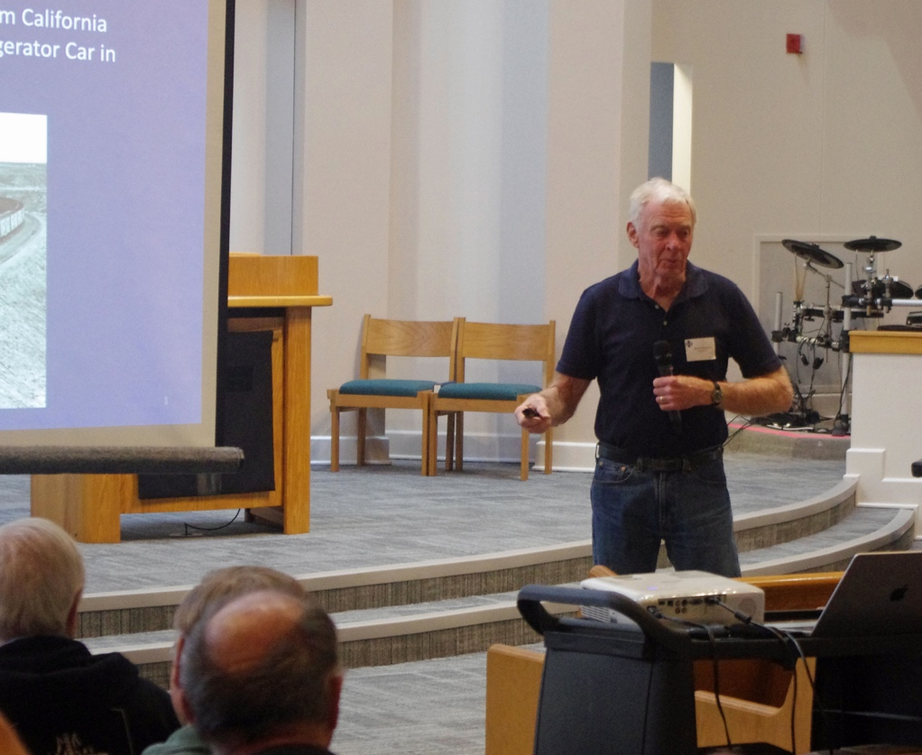
Our first presenter was Bruce McKeown who shared the story of an iced reefer car traveling from California to New York City.

Steve Cigolle shared photos from a railfan trip that he took on the Santa Fe Clovis Sub prior to the merger.

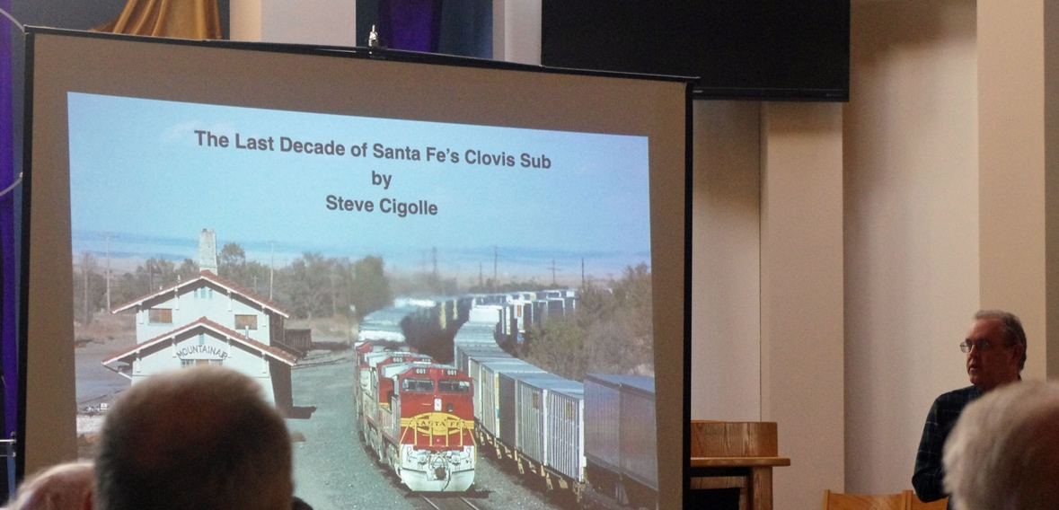

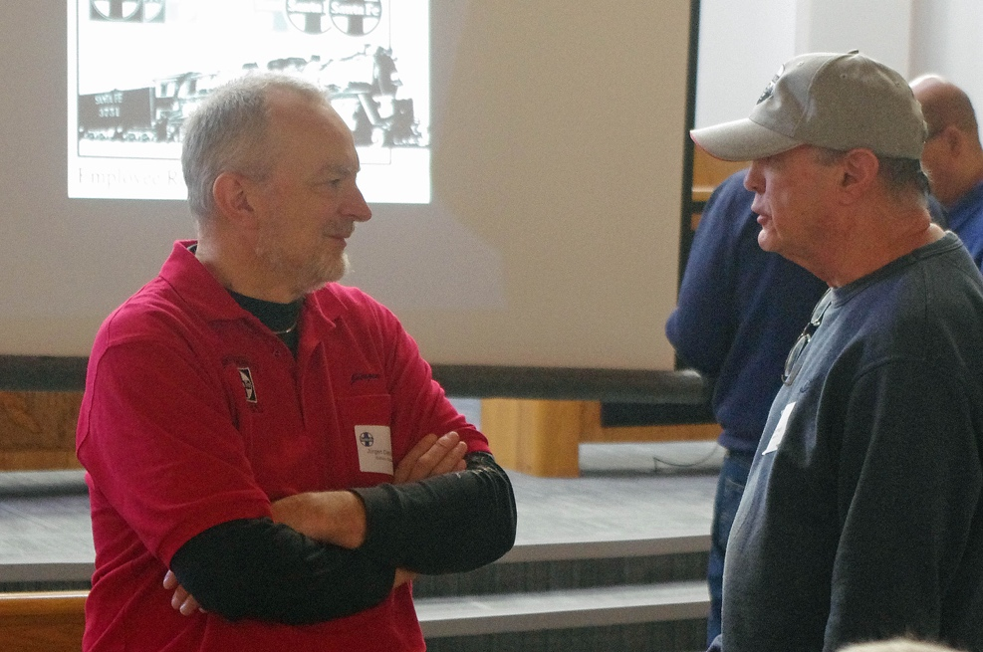
Jürgen Dietrichkeit shared how he built his signaling system for his home layout of the Santa Fe Clovis Sub.

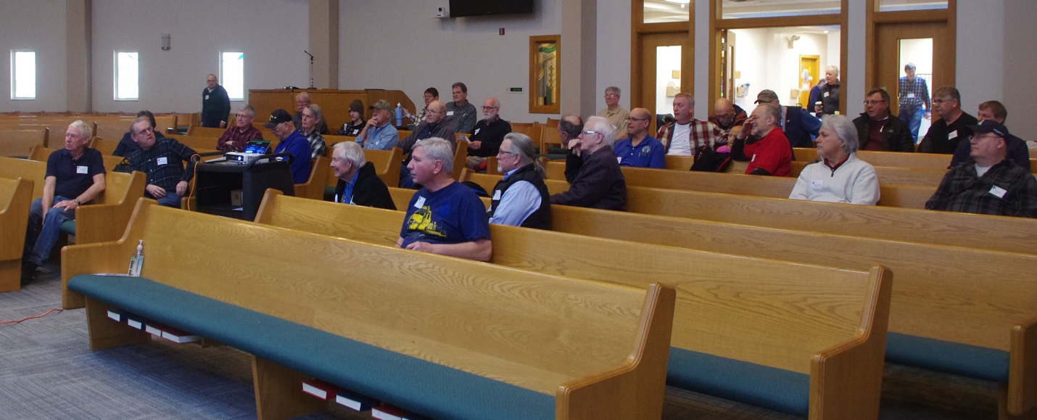
James Brown provided some very revealing stories from interviewing over 40 ATSF employees as he researched his most recent books. We all wish that we could have been there in the room with him during some of those interviews.

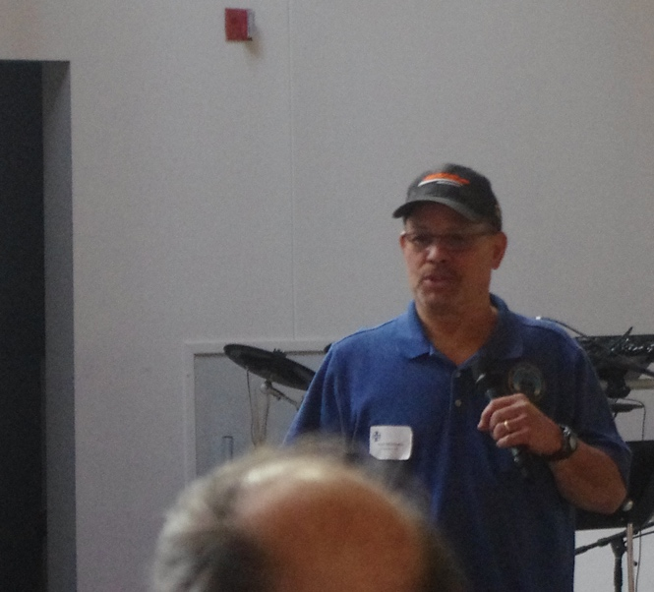
Keel Middleton shared his six days of accompanying and working with the 1992 Santa Fe Employee Appreciation train. Especially interesting were his experiences with the 3751 as it traveled from California to Chicago. We all wished we could have been with him for some of that!

We had swap tables again and a number of bargains and special finds were available for all. Paul Brown and Tom Cain again had their layouts available for visitors.

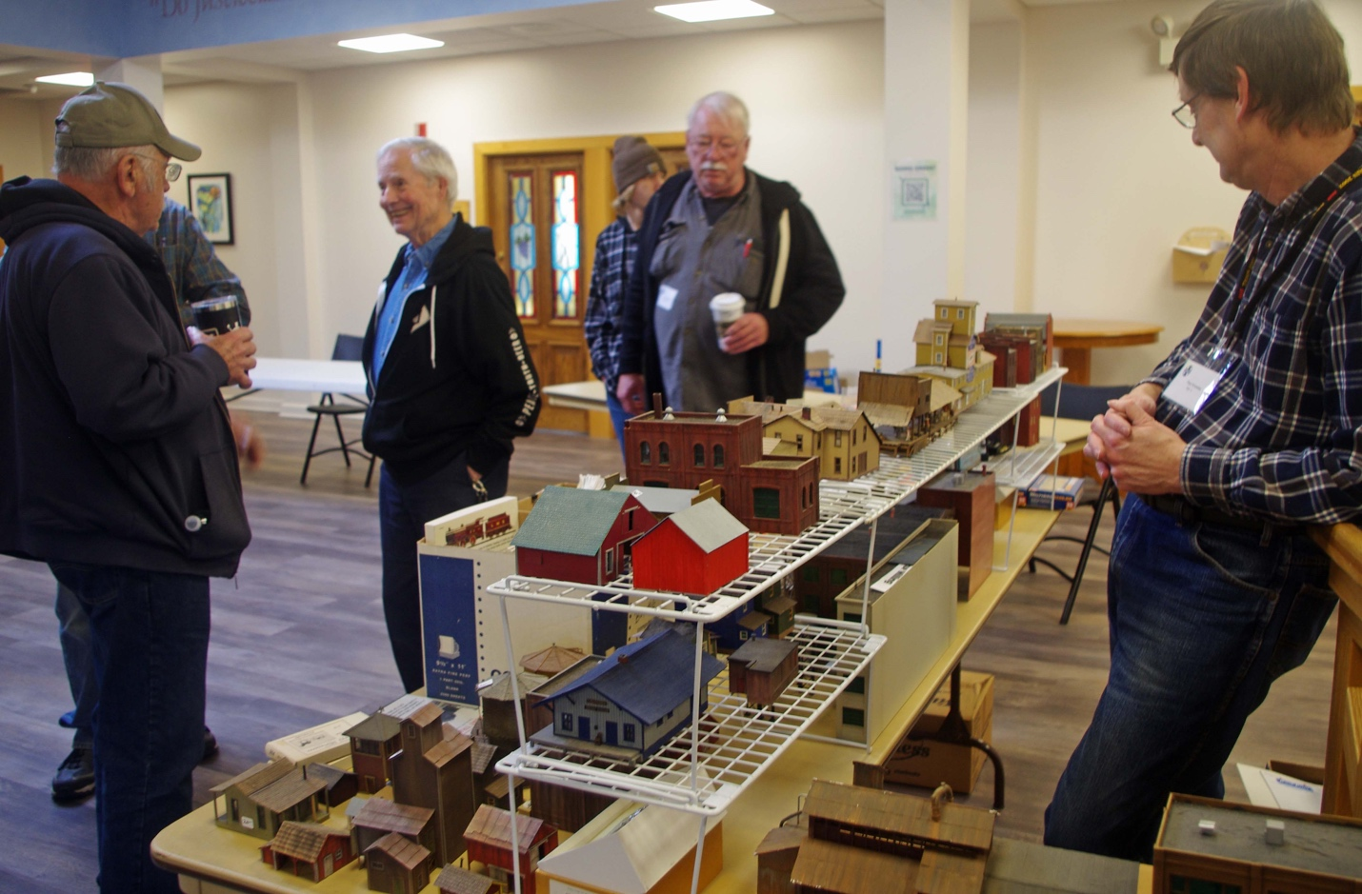

Next Year!!! We will be the guest of the Indiana Rail Road at 1500 S. Senate Avenue on March 14, 2026 where we will learn the history and tour El Capitan Lounge Car #1389. Watch for more information on this new development!

